**Module Assignment**

**Module 2**

**QMB-6304 Foundations of Business Statistics**

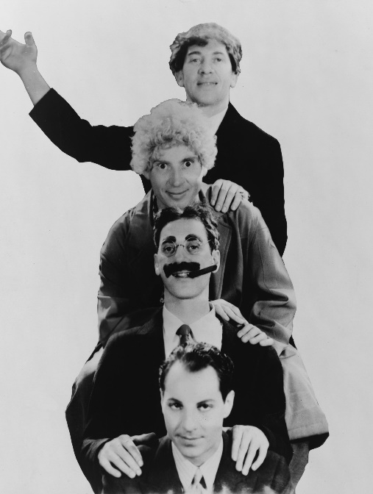

Write a simple R script to execute the following:

**Preprocessing:**

Load the data in “6304 Assignment 2 Data.xlsx” into an object. The file includes 10000 observations for each of four variables, which are creatively named for the four Marx Brothers.

**#Carolina Aldana Yabur**

**#UID: U25124553**

**rm(list=ls())**

**install.packages("rio")**

**install.packages("moments")**

**library(rio)**

**library(moments)**

**mydata=import("6304 Module 2 Assignment Data.xlsx")**

**colnames(mydata)=tolower(make.names(colnames(mydata)))**

**attach(mydata)**

**Analysis:**

1. Use common tools to determine whether any of the four variables are normally distributed. Explain how you arrived at your conclusions.

**#Histogram and Density Plot**

**hist(harpo, col="red", main= "Harpo Histogram", probability=TRUE)**

**plot(density(harpo),lwd=3, main="Harpo Density plot")**

**lines(density(harpo),lwd=3,col="blue")**

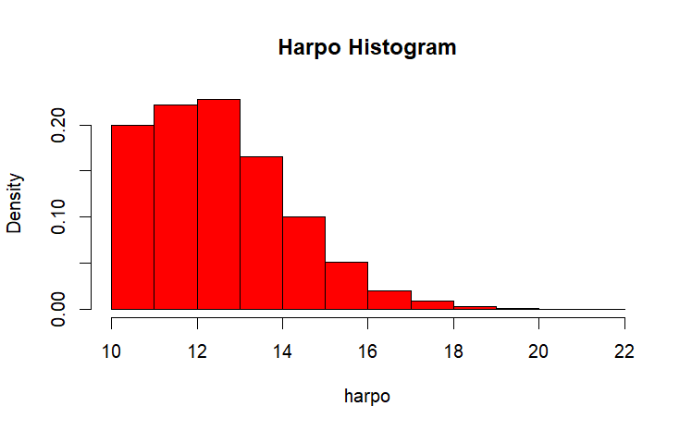

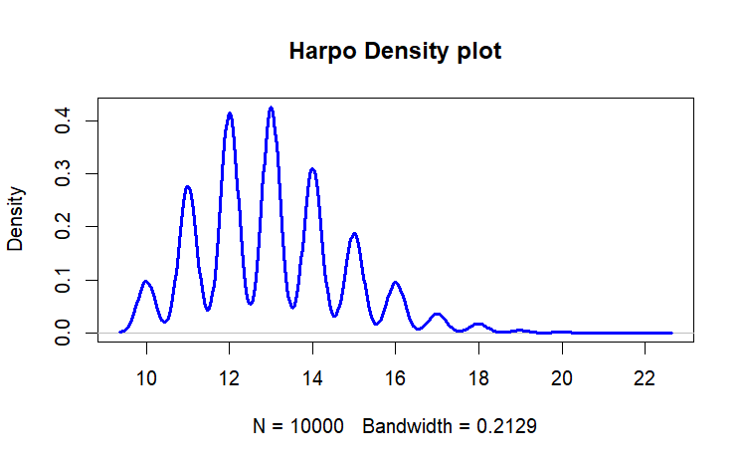

**hist(harpo, col="red", main= "Harpo's Histogram and Density Plot", probability=TRUE)**

**lines(density(harpo), lwd=3, col="blue")**

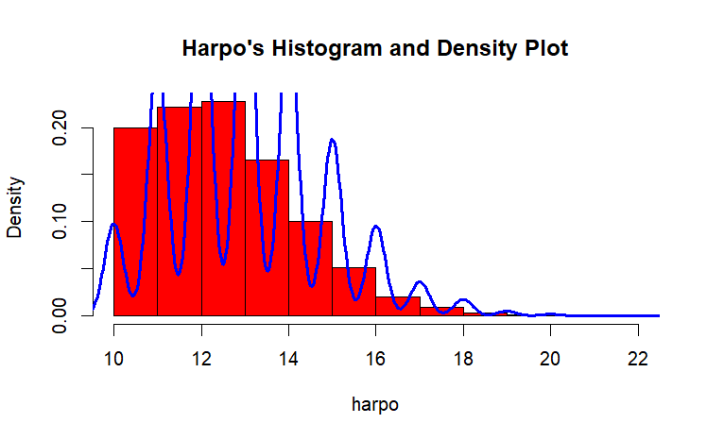

The histogram and density plot of the variable Harpo suggest that the distribution is not normal, since both histogram and density plot show that the bulk of data is on the left and the longer tail for both is on the right side, appearing right skewed.

**#QQ Plot**

**qqnorm(harpo, pch=19, main="Harpo QQ Plot")**

**qqline(harpo, col="red", lwd=3)**

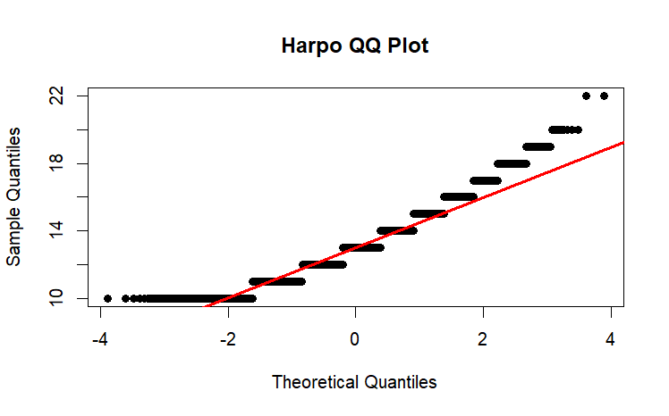

The QQ plot suggests that most of the data do not follow a normal distribution as the lines are not lining up.

**> #Objective Measures**

**> skewness(harpo)**

**[1] 0.5786532**

**> kurtosis(harpo)**

**[1] 3.364361**

The skewness is greater than 0 which suggests that the data points are concentrated on the left side. On the other hand, the kurtosis is greater than 3, which suggests that the distribution is leptokurtic (heavy tails and sharp peak) and not normal.

**#Zeppo**

**#Histogram and Density Plot**

**hist(zeppo, col="red", main= "Zeppo Histogram", probability=TRUE)**

**plot(density(zeppo),lwd=3, main="Zeppo Density plot")**

**lines(density(zeppo),lwd=3,col="blue")**

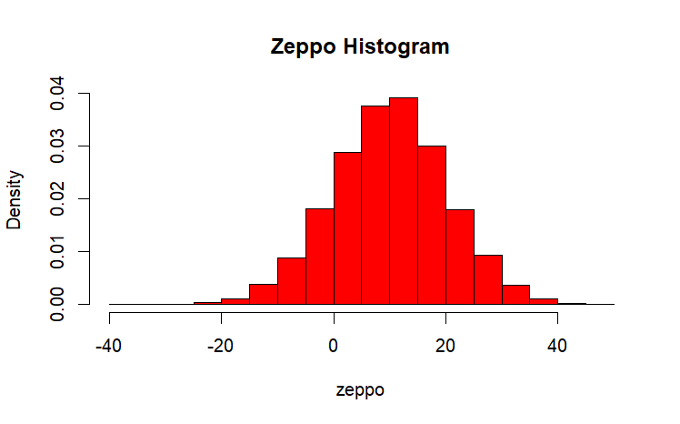

**hist(zeppo, col="red", main= "Zeppo's Histogram and Density Plot", probability=TRUE)**

**lines(density(zeppo), lwd=3, col="blue")**

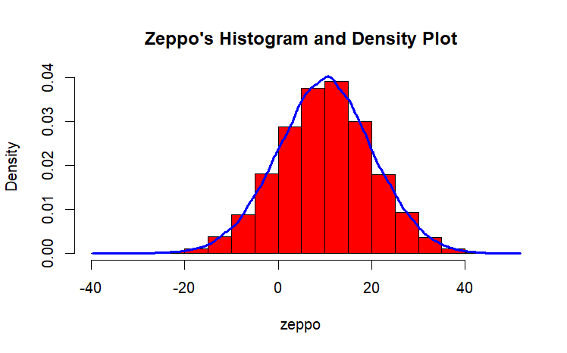

The histogram and density plot of the variable Zeppo suggest that the distribution is normal, since the bulk of data is concentrated around the mean of the variable (10.06). Both of them look like a smooth bell curve.

**#QQ Plot**

**qqnorm(zeppo, pch=19, main="Zeppo QQ Plot")**

**qqline(zeppo, col="red", lwd=3)**

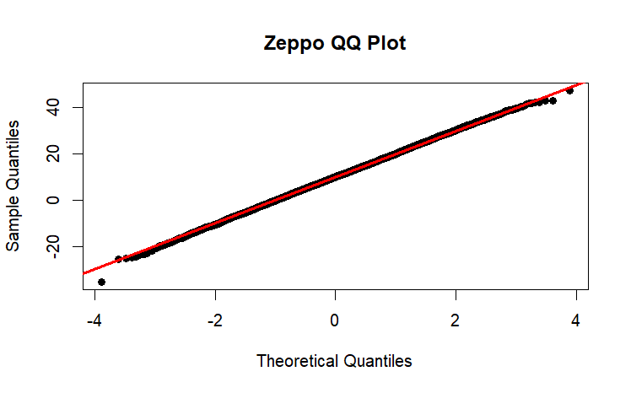

The QQ plot suggests that most of the data follow normal distribution.

**> #Objective Measures**

**> skewness(zeppo)**

**[1] -0.0245893**

**> kurtosis(zeppo)**

**[1] 3.019482**

The skewness is very close to 0 and suggests that is approximately symmetric, the kurtosis is also very close to 3 which suggests the same thing.

**#Groucho**

**#Histogram and Density Plot**

**hist(groucho, col="red", main= "Groucho Histogram", probability=TRUE)**

**plot(density(groucho),lwd=3, main="Groucho Density plot")**

**lines(density(groucho),lwd=3,col="blue")**

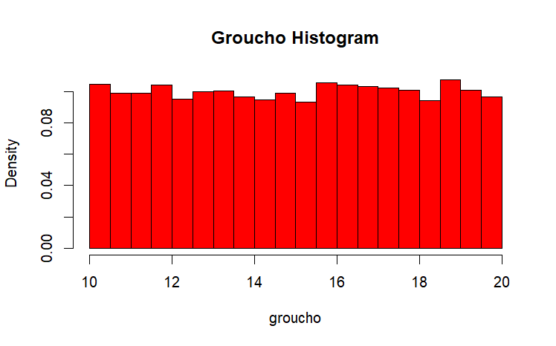

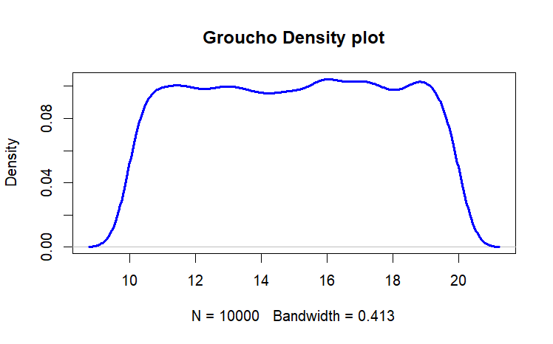

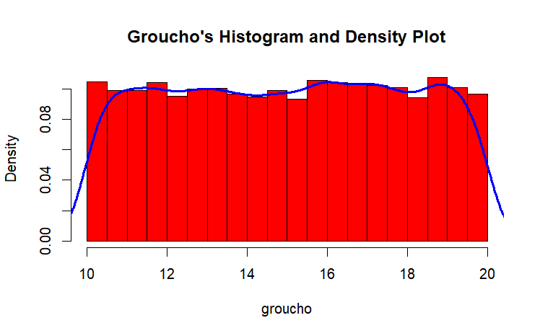

The histogram and density plot of the variable Groucho suggest that the distribution is not normal since both are relatively flat, suggesting that it has a uniform distribution.

**#QQ Plot**

**qqnorm(groucho, pch=19, main="Groucho QQ Plot")**

**qqline(groucho, col="red", lwd=3)**

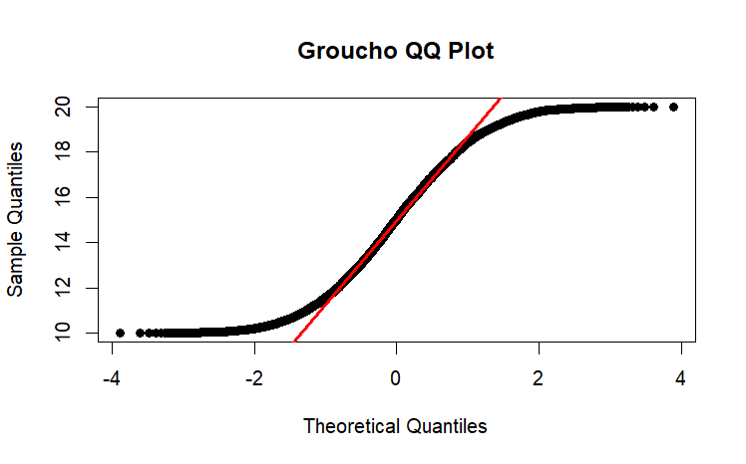

The QQ plot suggests that most of the data does not follow a normal distribution since it is deviating from the red diagonal line.

**> #Objective Measures**

**> skewness(groucho)**

**[1] -0.01466599**

**> kurtosis(groucho)**

**[1] 1.795703**

The skewness is not close enough to 0 to suggest it is a normal distribution. Likewise, the kurtosis is less than 3 and suggests the distribution is platykurtic but not normal.

**#Chico**

**#Histogram and Density Plot**

**hist(chico, col="red", main= "Chico Histogram", probability=TRUE)**

**plot(density(chico),lwd=3, main="Chico Density plot")**

**lines(density(chico),lwd=3,col="blue")**

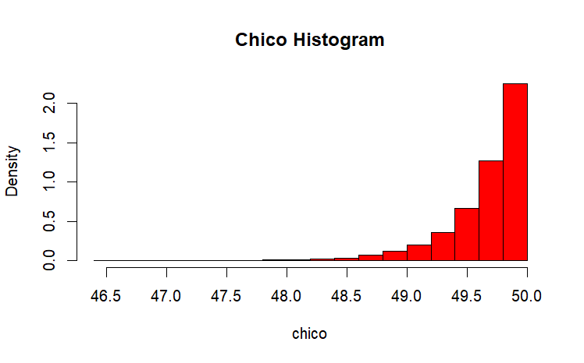

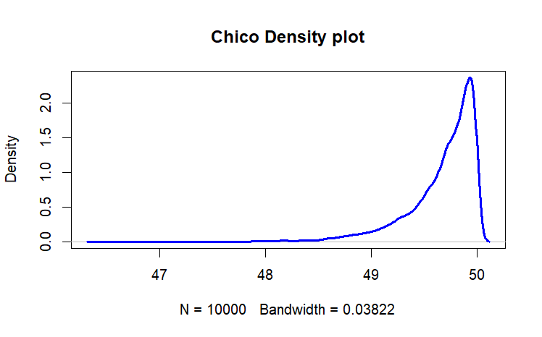

**hist(chico, col="red", main= "Chico's Histogram and Density Plot", probability=TRUE)**

**lines(density(chico), lwd=3, col="blue")**

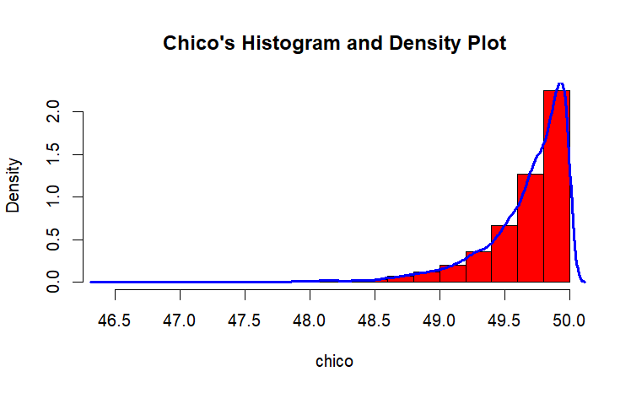

The histogram and density plot of the variable Chico suggest that the distribution is not normal, since both histogram and density plot show that the bulk of data is on the right and the longer tail for both is on the left side, appearing left skewed.

**#QQ Plot**

**qqnorm(chico, pch=19, main="Chico QQ Plot")**

**qqline(chico, col="red", lwd=3)**

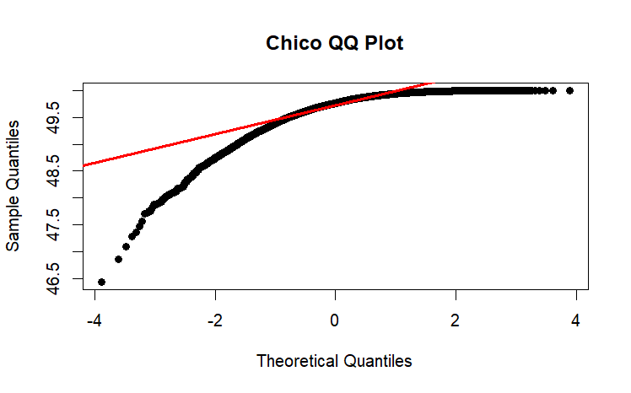

The QQ plot suggests that most of the data does not follow a normal distribution since it is deviating from the red diagonal line.

**> #Objective Measures**

**> skewness(chico)**

**[1] -2.031371**

**> kurtosis(chico)**

**[1] 9.268749**

The skewness is lower than 0 which suggests that the data points are concentrated on the right side. On the other hand, the kurtosis is greater than 3, which suggests that the distribution is leptokurtic (heavy tails and sharp peak) and not normal.

1. Focus on the Chico variable. Build a sampling distribution of the population mean by calculating the mean for each of 1000 samples of n=40. Plot the sampling distribution with an appropriate graph title. Verify whether these 1000 means are in fact normally distributed and justify your conclusion with appropriate analytics and/or graphical tools.

**set.seed(1000)**

**n=40**

**brothers_sample=rep()**

**for (x in 1:1000){**

**brothers_sample[x]=mean(sample(chico,40))**

**hist(brothers_sample, col="red",**

**main= "Sample Means of Variable Data",**

**xlab="Sample Means")**

**plot(density(brothers_sample), lwd=3,**

**main= "Density Plot of Variable Samples")**

**hist(brothers_sample, col="red",**

**main="Density - Histogram of Sample Data",**

**xlab= "Sample Means", probability= TRUE)**

**lines(density(brothers_sample), lwd=3, col="blue")**

**qqnoem(brothers_sample, col="red", lwd=3,**

**main= "QQ Plot of Variable Samples")**

**qqline(brothers_sample, col="red", lwd=3)**

**skeweness(brothers_sample)**

**kurtosis(brothers_sample)**

**}**

Your deliverable will be a single MS-Word file showing 1) the R script which executes the above instructions and 2) the results of those instructions. The first line of your script file should be a “#” comment line showing your name as it appears in Canvas. Results should be presented in the order in which they are listed here. Deliverable due time will be announced in class and on Canvas. **This is an individual assignment to be completed before you leave the classroom. No collaboration of any sort is allowed on this assignment.**